Gas Pressure and Volume

Experiment: You must use a calculator that has the EasyData application during the data collection phase of this experiment!

- Prepare the Gas Pressure Sensor and an air sample for data collection.
  - Plug the Gas Pressure Sensor into CH 1 of the CBL2, and use the link cable to connect one of your calculators to the CBL2.
  - Pull the syringe to the 10-mL mark and connect it to the Gas Pressure Sensor. Turn the syringe clockwise until it is secure.

- Turn on the calculator and start EasyData. Respond to any prompts generated to get to the main screen. The Gas Pressure Sensor should automatically be detected and a current reading displayed.
  - Select the Setup tab.
  - From the menu options displayed select 1: CH1:PRESS, then select the Units tab and select from the type of units you wish to measure pressure in. Now hit the OK tab to return to the main menu.
  - Again select the Setup tab and this time from the menu of options displayed select 3: Events with Entry.

Check with your facilitator

- Collect pressure and volume data.
  - Select the Start tab to begin data collection.
  - Move the syringe so the front edge of the inside black ring (see figure) is positioned at the 5.0-mL line on the syringe. Hold the syringe firmly in position until the pressure value stabilizes.

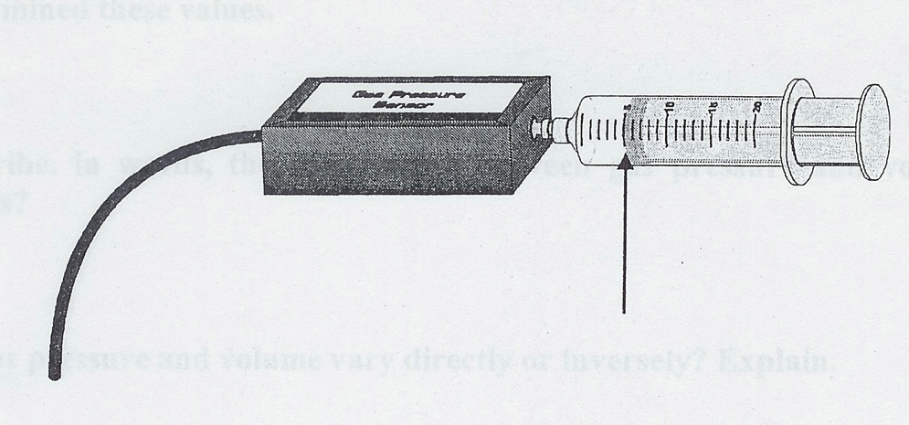

  - Press the Keep tab and type in the Enter Value box displayed a 5, the gas volume (mL). Then press the OK tab. The calculator will store the pressure value from the sensor and the entered volume value. The resulting data point is then displayed on a graph.
  - You can now repeat this procedure to collect additional data points. Do so for volumes of 7.5-mL, 10.0-mL, 12.5-mL, 15.0-mL, 17.5-mL, and 20.0-mL.
  - Select the Stop tab when you have finished collecting data.
- Select the Main tab return to the main screen and select the Quit tab to exit the EasyData application and analyze the data outside of the application. The calculator will tell you where your data has been stored record this and select the OK tab. Now link and share this data with your group members!
- Use your stats tools to create a scatter plot of your data.
Processing the Data: Only use your calculator to view the lists & graph at this time!

- Look at your lists of the data and note the gas pressure when the volume is 10.0-mL, and when the volume is 5.0-mL. What happened to the pressure when the volume was halved?

- Look at your lists of the data and note the gas pressure when the volume is 10.0-mL, and when the volume is 20.0-mL. What happened to the pressure when the volume was doubled?

- From your data and graph, what is the pressure when the volume is 16-mL? 8-mL? How do these values compare?

- What would the pressure be at 40.0-mL? At 2.5-mL? Explain how you determined these values.

- Describe, in words, the relationship between gas pressure and volume.

- Do gas pressure and volume vary directly or inversely? Explain.

- Write an equation to express the relationship between gas pressure and volume. Use the symbols P, V, and k (constant).

