Graphically Speaking

Milli and Deci walk home from school every day. One afternoon, Deci leaves the school and runs to the ice cream store. He orders an ice cream cone and then walks the rest of the way home. That same afternoon, Milli played on the swings with some of the other children before she started to walk home. She was about halfway home when she started to run. Use the graphs to help you answer the questions that follow.

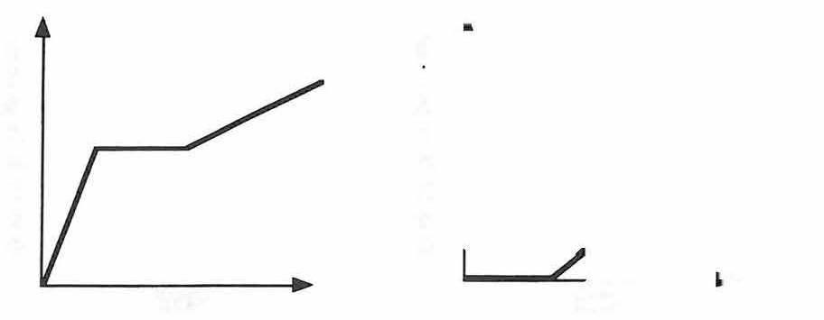
d
s
i
d
I
t
s
a
t
n
a
n
e
C
C
e
time·
time

1) On the graph of distance versus time, what point could represent the moment when Milli or Deci is at school at the end of the day? Explain how you know.

2) How can you represent time spent staying after school for soccer practice?

3) Describe the similarities and differences between a person running and a person walking.

4) Which graph best describes Milli’s trip home from school? Explain how you know.

5) Which graph best describes Deci’s trip? Explain how you know.

