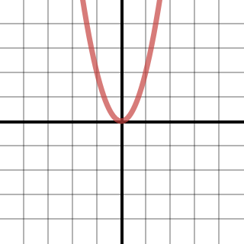  Graph 1 | 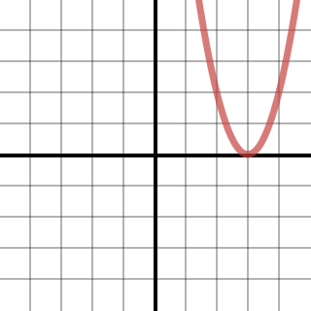  Graph 2 | 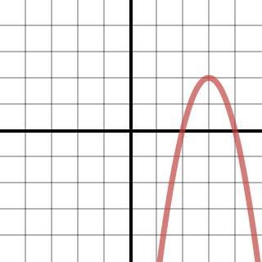  Graph 3
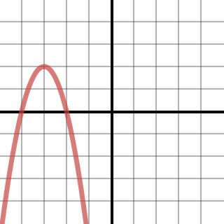  Graph 4 | 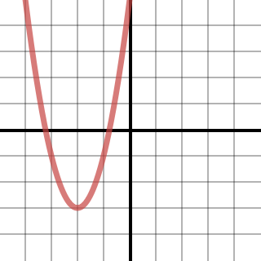  Graph 5 | 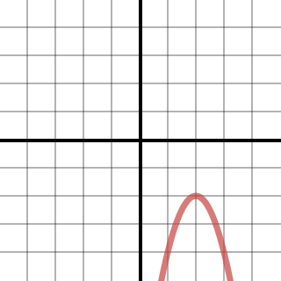  Graph 6
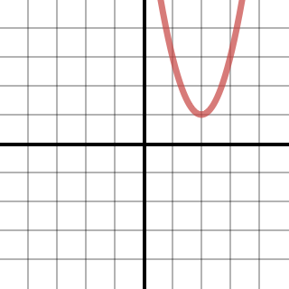  Graph 7 | 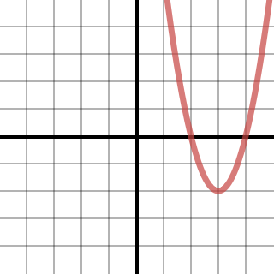  Graph 8 | 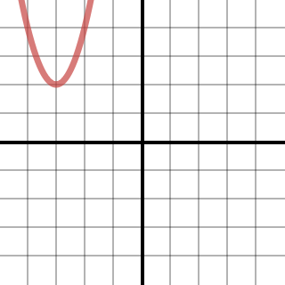  Graph 9
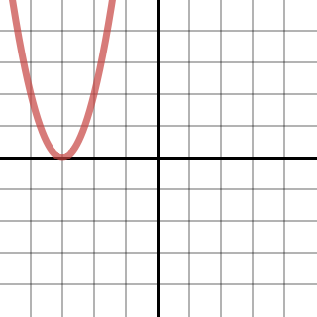  Graph 10 | 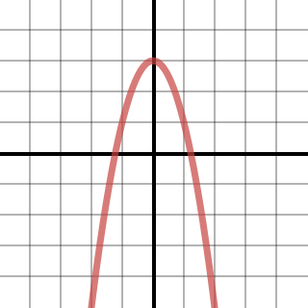  Graph 11 | 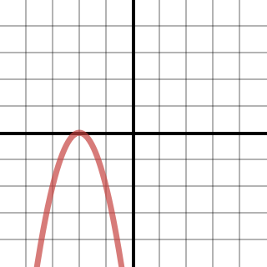  Graph 12
$$y=x^{2}$$ | $$y=x^{2}-6x+9$$ | $$y=-x^{2}+6x-7$$
$$y=-x^{2}-6x-7$$ | $$y=x^{2}+4x+1$$ | $$y=-x^{2}+4x-6$$
$$y=x^{2}-4x+5$$ | $$y=x^{2}-6x+7$$ | $$y=x^{2}+6x+11$$
$$y=x^{2}+6x+9$$ | $$y=-x^{2}+3$$ | $$y=-x^{2}-4x-4$$
$$\left(0,0\right)$$  Vertex | $$(3,0)$$  Vertex | $$(3,2)$$  Vertex
$$(-3,2)$$  Vertex | $$(-2,-3)$$  Vertex | $$(2,-2)$$  Vertex
$$(2,1)$$  Vertex | $$(3,-2)$$  Vertex | $$(-3,2)$$  Vertex
$$(-3,0)$$  Vertex | $(0,$3$)$  Vertex | $$(-2,0)$$  Vertex
Opens Up | Opens Up | Opens Down
Opens Down | Opens Up | Opens Down
Opens Up | Opens Up | Opens Up
Opens Up | Opens Down | Opens Down
$$(-∞,∞)$$  Domain | $$(-∞,∞)$$  Domain | $$(-∞,∞)$$  Domain
$$(-∞,∞)$$  Domain | $$(-∞,∞)$$  Domain | $$(-∞,∞)$$  Domain
$$(-∞,∞)$$  Domain | $$(-∞,∞)$$  Domain | $$(-∞,∞)$$  Domain
$$(-∞,∞)$$  Domain | $$(-∞,∞)$$  Domain | $$(-∞,∞)$$  Domain
$$[0,∞)$$  Range | $$[0,∞)$$  Range | $$(-∞,2]$$  Range
$$(-∞,2]$$  Range | $$[-3,∞)$$  Range | $$(-∞,-2]$$  Range
$$[1,∞)$$  Range | $$[-2,∞)$$  Range | $$[2,∞)$$  Range
$$[0,∞)$$  Range | $$(-∞,3]$$  Range | $$(-∞,0]$$  Range
$$x=0$$  Axis of Symmetry | $$x=3$$  Axis of Symmetry | $$x=3$$  Axis of Symmetry
$$x=-3$$  Axis of Symmetry | $$x=-2$$  Axis of Symmetry | $$x=2$$  Axis of Symmetry
$$x=2$$  Axis of Symmetry | $$x=3$$  Axis of Symmetry | $$x=-3$$  Axis of Symmetry
$$x=-3$$  Axis of Symmetry | $$x=0$$  Axis of Symmetry | $$x=-2$$  Axis of Symmetry
$$(0,0)$$  y-intercept | $$(0,9)$$  y-intercept | $$(0,-7)$$  y-intercept
$$(0,-7)$$  y-intercept | $$(0,1)$$  y-intercept | $$(0,-6)$$  y-intercept
$$(0,5)$$  y-intercept | $$(0,7)$$  y-intercept | $$(0,11)$$  y-intercept
$$(0,9)$$  y-intercept | $$(0,3)$$  y-intercept | $$(0,-4)$$  y-intercept
$$(0,0)$$  1 x-intercept | $$(3,0)$$  1 x-intercept | $$\left(1.6,0\right)$$  and  $$\left(4.4,0\right)$$  2 x-intercepts
$$\left(-1.6,0\right)$$  and  $$\left(-4.4,0\right)$$  2 x-intercepts | $$\left(-0.3,0\right)$$  and  $$\left(-3.7,0\right)$$  2 x-intercepts | $$None$$  0 x-intercepts
$$None$$  0 x-intercepts | $$\left(1.6,0\right)$$  and  $$\left(4.4,0\right)$$  2 x-intercepts | $$None$$  0 x-intercepts
$$(-3,0)$$  1 x-intercept | $$(-1.7,0)$$  and  $$(1.7,0)$$  2 x-intercepts | $$(-2,0)$$  1 x-intercept

