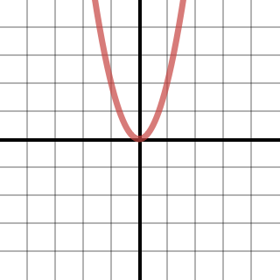  Graph 1 | 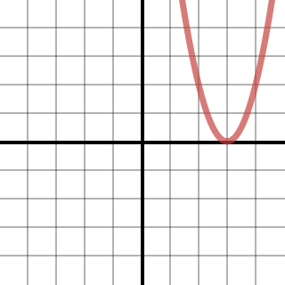  Graph 2 | 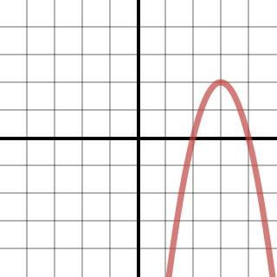  Graph 3
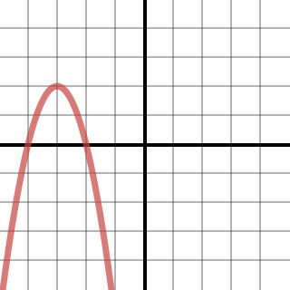  Graph 4 | 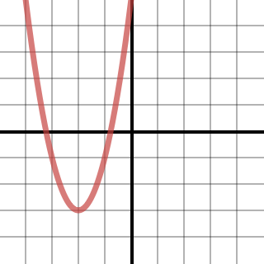  Graph 5 | 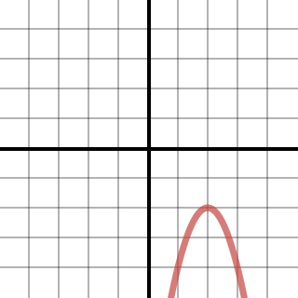  Graph 6
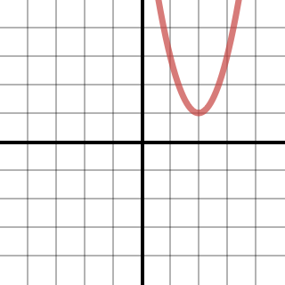  Graph 7 | 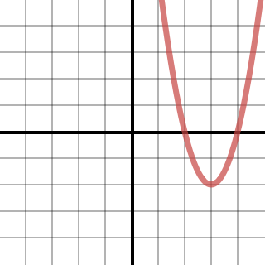  Graph 8 | 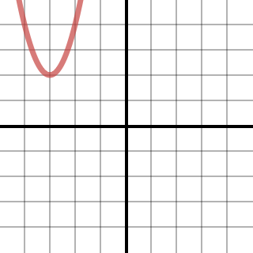  Graph 9
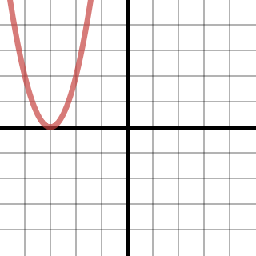  Graph 10 | 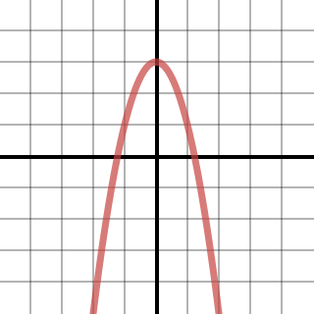  Graph 11 | 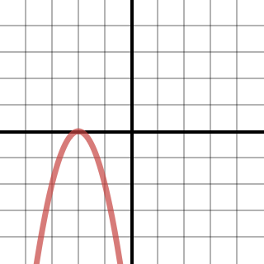  Graph 12
$$y=x^{2}$$ | $$y={(x-3)}^{2}$$ | $$y={-(x-3)}^{2}+2$$
$$y={-(x+3)}^{2}+2$$ | $$y={(x+2)}^{2}-3$$ | $$y={-(x-2)}^{2}-2$$
$$y={(x-2)}^{2}+1$$ | $$y={(x-3)}^{2}-2$$ | $$y={(x+3)}^{2}+2$$
$$y={(x+3)}^{2}$$ | $$y=-x^{2}+3$$ | $$y={-(x+2)}^{2}$$
$$\left(0,0\right)$$  Vertex | $$(3,0)$$  Vertex | $$(3,2)$$  Vertex
$$(-3,2)$$  Vertex | $$(-2,-3)$$  Vertex | $$(2,-2)$$  Vertex
$$(2,1)$$  Vertex | $$(3,-2)$$  Vertex | $$(-3,2)$$  Vertex
$$(-3,0)$$  Vertex | $(0,$3$)$  Vertex | $$(-2,0)$$  Vertex
Opens Up | Opens Up | Opens Down
Opens Down | Opens Up | Opens Down
Opens Up | Opens Up | Opens Up
Opens Up | Opens Down | Opens Down
$$(-∞,∞)$$  Domain | $$(-∞,∞)$$  Domain | $$(-∞,∞)$$  Domain
$$(-∞,∞)$$  Domain | $$(-∞,∞)$$  Domain | $$(-∞,∞)$$  Domain
$$(-∞,∞)$$  Domain | $$(-∞,∞)$$  Domain | $$(-∞,∞)$$  Domain
$$(-∞,∞)$$  Domain | $$(-∞,∞)$$  Domain | $$(-∞,∞)$$  Domain
$$[0,∞)$$  Range | $$[0,∞)$$  Range | $$(-∞,2]$$  Range
$$(-∞,2]$$  Range | $$[-3,∞)$$  Range | $$(-∞,-2]$$  Range
$$[1,∞)$$  Range | $$[-2,∞)$$  Range | $$[2,∞)$$  Range
$$[0,∞)$$  Range | $$(-∞,3]$$  Range | $$(-∞,0]$$  Range

